SIMATS ENGINEERING (SAVEETHA SCHOOL OF ENGINEERING)
Department of Computer Science and Engineering
CO3 ASSESSMENT TOOL 1 — Git & Docker Technical Assignment
Smart Mining Operations and Safety Management Platform
Course Code: | CSA1007
Course Title: | Software Engineering
CO Assessed: | CO3
Assessment: | Assessment Tool 1 – Git & Docker Technical Assignment
Weightage: | 20%
Total Marks: | 25
Student Name: | Jahnavi Maddi
Reg. No.: | 192411196
Date: | 08/08/2026
Duration: | 60 minutes

Code of Conduct: I, Jahnavi Maddi (Reg. No. 192411196), certify that this submission is my original work and that I have adhered to the guidelines specified for this assessment. I understand that any violation of academic integrity rules will result in disciplinary action.

Signature of the Student: ____________________________

1. Problem Analysis
1.1 Problem Statement
The assigned problem statement is the Smart Mining Operations and Safety Management Platform, a software system designed to improve safety, coordination, and operational efficiency within underground and open-pit mining sites. Mining environments are inherently hazardous due to confined spaces, toxic gas exposure, equipment failures, and communication difficulties between workers and control rooms. The platform is intended to digitize and automate the monitoring of workers, machinery, and environmental conditions so that hazards can be identified and addressed before they result in accidents.
1.2 Project Objectives
- Track worker locations in real time across the mining site using positioning sensors and wearable devices.
- Monitor environmental conditions such as gas concentration, temperature, humidity, and air quality continuously.
- Detect safety hazards including gas leaks, structural instability, and restricted-zone breaches, and raise alerts automatically.
- Predict equipment failures using sensor data and historical maintenance records to enable predictive maintenance.
- Coordinate emergency response by notifying response teams and guiding evacuation when a hazard is detected.
- Generate safety reports summarizing incidents, compliance status, and operational KPIs for management review.
1.3 Functional Requirements
- Real-time worker location tracking with a live map view of the mine layout.
- Continuous ingestion and analysis of environmental sensor data (gas, temperature, dust, humidity).
- Automated hazard detection engine with configurable threshold-based and rule-based alerts.
- Predictive maintenance module that analyzes equipment telemetry to forecast failures.
- Emergency response coordination module with alert broadcasting and evacuation route guidance.
- Reporting module to generate daily/weekly/monthly safety and compliance reports.
- Role-based access control for site supervisors, safety officers, and administrators.
- REST APIs to integrate with third-party IoT sensor networks and SCADA systems.
1.4 Expected Outcomes
- Improved worker safety through continuous, real-time hazard visibility.
- Reduced accident rates as a result of early hazard detection and preventive alerts.
- Faster emergency response through automated notification and coordination workflows.
- Lower equipment downtime achieved via predictive maintenance scheduling.
- Better operational visibility for management through consolidated dashboards and reports.

2. Project Structure Design
2.1 Repository Folder Structure
smart-mining-safety-platform/
├── backend/
│ ├── src/
│ │ ├── controllers/
│ │ ├── services/
│ │ ├── models/
│ │ ├── routes/
│ │ ├── middleware/
│ │ └── utils/
│ ├── tests/
│ ├── Dockerfile
│ └── package.json
├── frontend/
│ ├── src/
│ │ ├── components/
│ │ ├── pages/
│ │ └── services/
│ ├── Dockerfile
│ └── package.json
├── ml-service/
│ ├── model/
│ ├── app.py
│ └── Dockerfile
├── docs/
│ ├── architecture-diagram.png
│ └── workflow-diagram.png
├── docker-compose.yml
├── .env.example
├── .gitignore
├── README.md
└── LICENSE
(See the table below for the purpose of each folder and file listed above.)

2.2 Purpose of Major Folders and Files
Folder / File | Purpose
backend/ | Node.js/Express service handling worker tracking, hazard detection, alerts, and reporting APIs.
frontend/ | React-based dashboard for supervisors to view live maps, alerts, and reports.
ml-service/ | Python microservice hosting the predictive-maintenance model for equipment failure forecasting.
docker-compose.yml | Defines and orchestrates all services, networks, and volumes for local and production deployment.
.env.example | Documents required environment variables (DB credentials, API keys) without exposing secrets.
.gitignore | Excludes node_modules, build artifacts, and environment files from version control.
docs/ | Stores architecture and workflow diagrams referenced in the technical report.
README.md | Provides setup instructions, project overview, and usage guidance for collaborators.

3. Git Repository Initialization
3.1 Initialization Steps
- Created the project folder and initialized a local Git repository using git init.
- Configured user identity for commit attribution using git config user.name and git config user.email.
- Created a .gitignore file to exclude dependency folders, build outputs, and environment files.
- Added a README.md describing the project purpose, setup steps, and folder structure.
- Made the first commit ("Initial commit: project scaffolding") to establish the repository baseline.
- Created a remote repository on GitHub and linked it using git remote add origin, then pushed with git push -u origin main.
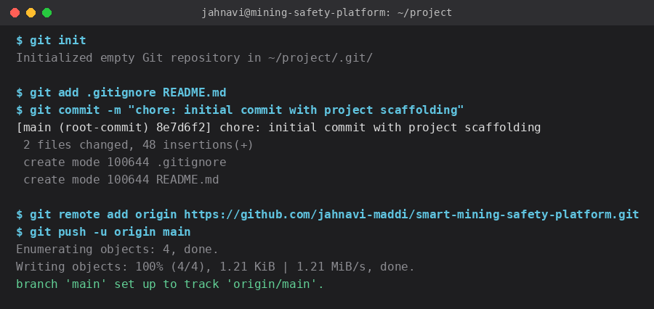
Fig 3.1 — Terminal output: repository initialization and first push to GitHub.
3.2 Purpose of Essential Git Files
File | Purpose
.git/ | Hidden directory storing the entire commit history, branches, and repository metadata.
.gitignore | Specifies files/folders (node_modules, .env, dist/) that Git should not track.
README.md | Human-readable documentation describing the project for new contributors.
.gitattributes | Normalizes line endings and marks binary files to ensure consistent behavior across platforms.

4. Git Branching Strategy
4.1 Branching Model
A Gitflow-inspired branching strategy was adopted, consisting of main, develop, feature, release, and hotfix branches. This model suits the project because it involves multiple independent modules (worker tracking, hazard detection, predictive maintenance, reporting) that can be developed in parallel while keeping the production branch stable for deployment to mine-site servers.
Branch | Purpose
main | Always reflects the stable, production-ready version deployed at the mine site.
develop | Integration branch where completed features are merged and tested together.
feature/* | Isolated branches for individual features, e.g. feature/worker-tracking, feature/hazard-alerts.
release/* | Prepares a stable build for deployment; used for final testing and documentation before merging to main.
hotfix/* | Used for urgent fixes to production issues, such as a false-negative hazard alert bug.
4.2 Justification
- Keeps the production (main) branch stable and deployable at all times, which is critical for a safety-related system.
- Allows parallel development of independent modules (tracking, hazard detection, prediction, reporting) without conflicts.
- Provides a clear path for urgent hotfixes to safety-critical bugs without disrupting ongoing feature work.
- Supports structured testing through release branches before features reach production.

5. Version Control Workflow
5.1 Demonstrated Git Operations
The workflow below shows a feature branch created from develop, meaningful commits, a push to the remote, a no-fast-forward merge back into develop, and resolution of a merge conflict in hazardDetection.js, followed by synchronization with the remote.
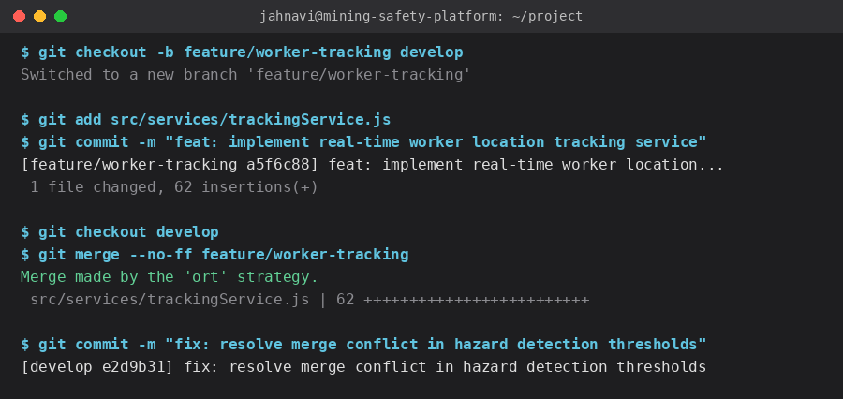
Fig 5.1 — Terminal output: feature branch commit, merge, and conflict resolution.
5.2 Purpose of Each Operation
Operation | Purpose
git checkout -b | Creates an isolated branch so new feature work does not affect stable code.
git add / commit | Records a meaningful, reviewable snapshot of changes with an explanatory message.
git push | Backs up local commits to the remote repository and shares work with the team.
git merge --no-ff | Integrates a completed feature into develop while preserving branch history for traceability.
Conflict resolution | Ensures overlapping changes (e.g., two developers editing hazard thresholds) are combined correctly.
git pull | Synchronizes local branch with the latest remote changes before continuing work.

6. Commit History Analysis
6.1 Sample Commit History
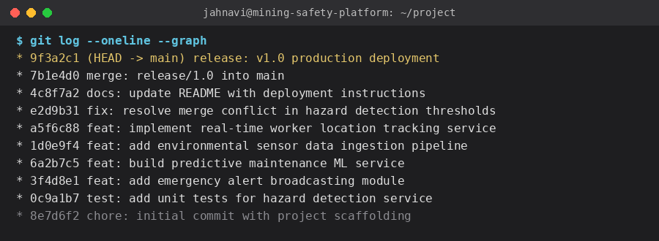
Fig 6.1 — Terminal output: full commit history (git log --oneline --graph).
6.2 Commit Message Practices
- Conventional prefixes (feat, fix, docs, chore, test) are used to categorize the intent of each commit at a glance.
- Each message is written in the imperative mood (e.g., "add", "fix", "implement") to describe the change concisely.
- Commits are scoped to a single logical change, which keeps the history easy to review, bisect, and revert if needed.
- Descriptive messages allow the team to reconstruct why a change was made months later, aiding maintenance and audits.

7. Docker Environment Design
7.1 Why Docker is Suitable
The platform consists of multiple independently deployable components — a backend API, a frontend dashboard, a machine-learning prediction service, and a database — each with different runtime dependencies. Docker allows every component to run in an isolated, reproducible container regardless of the host operating system used at different mine sites. This eliminates "it works on my machine" issues, simplifies deployment to edge servers located at remote mining locations, and allows the system to scale individual services independently as sensor volume grows.
7.2 Components Requiring Containerization
Component | Reason for Containerization
Backend API service | Handles tracking, alerts, and reporting logic; needs a consistent Node.js runtime across sites.
Frontend dashboard | Served as a static build via an isolated web server container (Nginx).
ML prediction service | Requires specific Python libraries (scikit-learn, pandas) isolated from the backend runtime.
Database (MongoDB/PostgreSQL) | Runs as a managed container with persistent volumes for sensor and worker data.
Message broker (MQTT/Redis) | Handles real-time sensor data streams between IoT devices and backend services.

8. Dockerfile Development
8.1 Backend Dockerfile
# backend/Dockerfile
FROM node:18-alpine AS base
WORKDIR /app

COPY package*.json ./
RUN npm install --production

COPY . .

ENV NODE_ENV=production
EXPOSE 5000

HEALTHCHECK --interval=30s --timeout=5s \
CMD wget -qO- http://localhost:5000/health || exit 1

CMD ["node", "src/server.js"]
8.2 Purpose of Each Instruction
Instruction | Purpose
FROM node:18-alpine | Uses a lightweight official Node.js base image to minimize image size.
WORKDIR /app | Sets the working directory inside the container for subsequent commands.
COPY package*.json ./ | Copies dependency manifests first to leverage Docker layer caching.
RUN npm install | Installs production dependencies inside the image.
COPY . . | Copies the rest of the application source code into the container.
ENV NODE_ENV=production | Configures the application to run in production mode.
EXPOSE 5000 | Documents the port the backend API listens on.
HEALTHCHECK | Allows Docker/Compose to detect and restart an unhealthy backend container.
CMD | Specifies the default command that starts the backend server.

9. Docker Compose Design
9.1 docker-compose.yml
version: "3.9"

services:
backend:
build: ./backend
ports:
- "5000:5000"
environment:
- MONGO_URI=mongodb://mongo:27017/mining_safety
- ML_SERVICE_URL=http://ml-service:6000
depends_on:
- mongo
- ml-service
networks:
- mining-net

frontend:
build: ./frontend
ports:
- "3000:80"
depends_on:
- backend
networks:
- mining-net

ml-service:
build: ./ml-service
ports:
- "6000:6000"
networks:
- mining-net

mongo:
image: mongo:6
volumes:
- mongo-data:/data/db
networks:
- mining-net

volumes:
mongo-data:

networks:
mining-net:
driver: bridge
9.2 Services, Networking, Volumes, and Dependencies
- Services: backend, frontend, ml-service, and mongo are defined as separate services, each built from its own Dockerfile or a public image.
- Networking: all services share a custom bridge network (mining-net) enabling them to communicate using service names as hostnames.
- Volumes: a named volume (mongo-data) persists database contents across container restarts and redeployments.
- Environment variables: connection strings (MONGO_URI, ML_SERVICE_URL) are injected via environment settings rather than hard-coded.
- Dependencies: depends_on ensures the backend starts only after mongo and ml-service are available, avoiding startup race conditions.

10. Container Deployment and Testing
10.1 Deployment Steps
All services were built and started with a single command using Docker Compose, which created the shared network and volume, then started the database, ML service, backend, and frontend containers in dependency order.
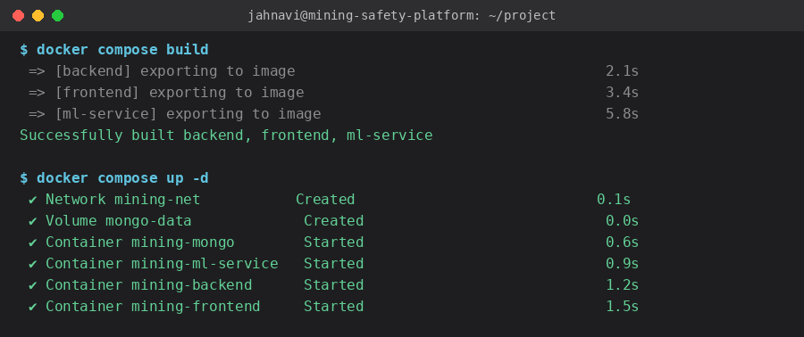
Fig 10.1 — Terminal output: image build and container startup via Docker Compose.
10.2 Testing Procedure and Evidence
- Verified backend health via GET http://localhost:5000/health, which returned a 200 OK status confirming the API and database connection were operational.
- Accessed the frontend dashboard at http://localhost:3000 and confirmed the live worker-location map and alerts panel rendered correctly.
- Simulated a gas-threshold breach by posting mock sensor data to the backend API and confirmed an alert was generated and displayed on the dashboard within seconds.
- Sent sample equipment telemetry to the ML service endpoint and confirmed a failure-probability score was returned, validating the predictive-maintenance pipeline.
- Captured screenshots of docker compose ps (all containers healthy), the health-check response, and the generated hazard alert as deployment evidence.
- Stopped and restarted the stack with docker compose down and docker compose up -d to confirm data persistence via the mongo-data volume.
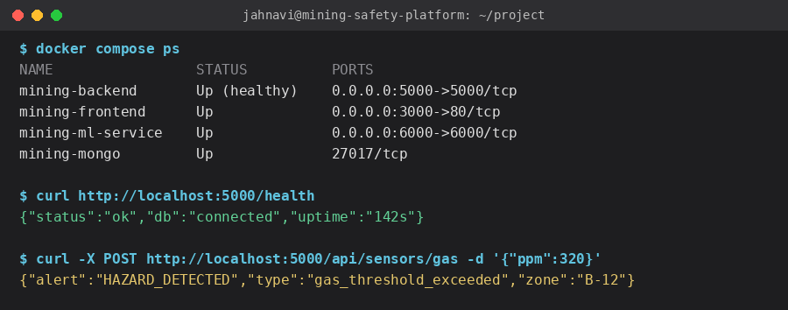
Fig 10.2 — Terminal output: container status check, health endpoint, and simulated hazard alert.

11. Benefits of Git and Docker
Benefit | How It Applies to This Project
Collaboration | Multiple developers can work on tracking, hazard detection, and prediction modules simultaneously using feature branches without overwriting each other's work.
Version management | Every change to safety-critical hazard-detection logic is tracked, reviewable, and revertible, which is essential for auditability.
Portability | Docker containers allow the platform to be deployed identically on cloud servers or on-premise edge servers at remote mine sites.
Deployment | Docker Compose enables one-command deployment of the full multi-service stack, reducing setup errors at new mining sites.
Scalability | Individual containers (e.g., ml-service) can be scaled independently as sensor data volume grows without affecting other services.
Maintainability | Clear branching history and isolated containers make it easier to diagnose, patch, and update individual components over time.

12. Challenges and Improvements
12.1 Challenges Encountered
- Merge conflicts arose when two features modified shared hazard-threshold configuration files simultaneously, requiring careful manual resolution.
- Coordinating environment variables and secrets (database URIs, API keys) securely across multiple containers required additional configuration discipline.
- Ensuring the ML service container had the correct Python dependency versions without bloating the image required iterative Dockerfile tuning.
- Simulating realistic IoT sensor data for testing hazard detection and predictive maintenance was time-consuming without live site hardware.
12.2 Suggested Improvements and Future Enhancements
- Introduce a CI/CD pipeline (e.g., GitHub Actions) to automatically run tests and build Docker images on every push to develop.
- Adopt a secrets manager (e.g., Docker Secrets or Vault) instead of plain environment variables for sensitive credentials.
- Add automated integration tests that spin up the full Docker Compose stack in CI to validate cross-service communication.
- Implement container orchestration with Kubernetes for multi-site, high-availability deployment as the number of mines grows.
- Expand the predictive maintenance model with real historical failure data to improve prediction accuracy over time.

